Larysa Kuzmenko is a Toronto-based composer and pianist. Her music has been performed and broadcast throughout the world. Her choral works have been published by Boosey and Hawkes. In March of 1992, Ms. Kuzmenko appeared as pianist in the premiere at Jane Mallet Theatre of her Sonata for Cello and Piano. This work was repeated on a Continuum concert in June of 1992, and was broadcast on Two New Hours in August of 1991. It was subsequently released on CD.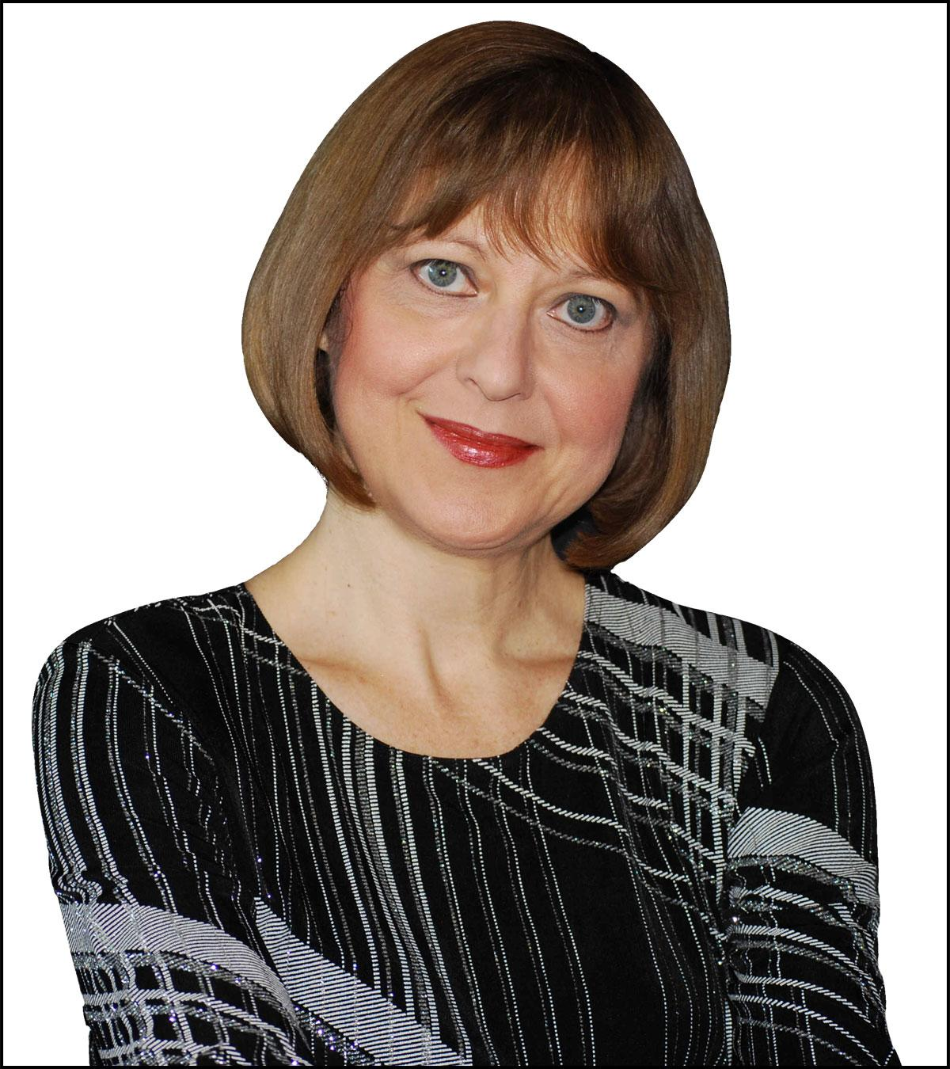

In 1992, the Royal Canadian College of Organists commissioned a new work for solo organ, “Atlantis”, which has been published by Jaymar Publishing Company. “Atlantis” was premiered by Michael Bloss on July 15, 1993, in Montreal. On February 19, 1993, “A Prayer for String Orchestra” was premiered by the Mississauga Sinfonia Chamber Orchestra. In March of 1993, Tekahionwake for narrator, voice, and piano, based on the life and poetry of Pauline Johnson, was premiered at the George Ignatieff Theatre. It was commissioned for Classical Cabaret by the Laidlaw Foundation. On July 24, 1993, The Composers' Orchestra premiered Kuzmenko's Accordion Concerto, with soloist Joseph Macerollo, conducted by Gary Kulesha. This was broadcast on Two New Hours in the fall of 1993.

Ms. Kuzmenko's Piano Concerto, commissioned by the CBC, was premiered on January 23, 1996 by the Winnipeg Symphony under the direction of Bramwell Tovey, with soloist Christina Petrowska. In October of 1996, it was performed by the Toronto Symphony Orchestra, conducted by Jukka Pekka Saraste and was released on CD by Centrediscs in 2010 ("Christina Petrowska Quilico", 3 Concerti) earning Larysa Kuzmenko a 2011 Juno nomination in the Classical Composition of the Year category. On July 6, 1998, her song cycle “In search of Eldorado” was premiered by mezzo soprano Catherine Robin. This work was commissioned by the Laidlaw Foundation, as was her “Suite of Dances” for flute, cello and piano, which was premiered at the Glenn Gould Studio, and released on CD by Musica Viva.

Her solo piano piece “In memoriam: to the Victims of Chernobyl'' (1997), was released on CD by Christina Petrowska. In November of 1998, Ms. Petrowska toured this work in New York City, China, and Taiwan. In January of 2002, Naida Cole performed this work at the Jane Mallet Theater. This work was subsequently performed throughout the world by several pianists.

In September of 2000, Ms. Kuzmenko was commissioned through the Ontario Arts Council to compose “Lilith”, for English Horn and string quartet, and a concerto for piano, percussion and string orchestra. “Lilith” was premiered at Jane Mallet Theatre by Mooredale Concerts, and the Concerto was premiered by Beverly Johnston, Mary Kenedi, and the Windsor Symphony, conducted by Susan Haig on January 12, 2001. Ms. Kuzmenko was commissioned by the Laidlaw Foundation to compose “Capriccio” for string quartet, percussion, and four flutes. This work was premiered on March 23, 2003, by Mooredale Concerts, with soloists Beverly Johnston and Vicky Blechta. She was commissioned by the Hannaford Street Silver Band to write a piano concerto that was premiered in November of 2002 with pianist Andrew Burashko and conducted by Gary Kulesha.

In June of 2003, her Impromptu and Toccata for Brass Quintet was premiered in Illinois by the Illinois State University Faculty Brass Quintet. This work was commissioned by the International Women's Brass Conference. “Entre Amis”, for solo cello and piano, was premiered at the Parry Sound Festival on July 20, 2003. This work was performed by Kristine Bogyo and Anton Kuerti. On November 15, 2003, “Voice of Hope” for soprano and string orchestra, commissioned by the Vesnivka Choir, was premiered in Toronto with soprano Katerina Tchoubar and the Composer's Orchestra conducted by Gary Kulesha. This work commemorated the 1932-1933 Famine-Genocide in Ukraine. “Dreams” for SATB Choir and Piano Trio was premiered on July 11, 2004, by the Elora Festival Singers and the Gryphon Trio, conducted by Noel Edison. This work was commissioned by the Festival and the Trio with the financial assistance of the Laidlaw Foundation, and was subsequently performed again by the Elora Singers with the Gryphon Trio at Jane Mallett Theatre, and then twice by the Iseler Singers with the Gryphon Trio, conducted by Doreen Rao. Ms. Kuzmenko's cello concerto was premiered on November 25 of 2004 by soloist Shauna Rolston with the Thunder Bay Orchestra, conducted by Geoffrey Moull, a performance that was broadcast by CBC Radio. This work was commissioned by Shauna Rolston through the Ontario Arts Council.

On March 2008 her choral piece “Gaude Virgo Gloriosa” was premiered at Victoria Chapel by the University of Women's Chorus. “Gaude Virgo Gloriosa” and “Dreams” have been chosen for publication with Boosey and Hawkes.

Kaori Yamagami premiered Ms. Kuzmenko's “Fantasy” for solo cello on November 20, 2008 in Toronto. This work was commissioned by the Toronto Women's Music Club. She has been recently commissioned to write a work for the Cantabile Choir in Kingston. In addition, Ms. Kuzmenko has been commissioned through the Ontario Arts Council to write an orchestral work using aboriginal themes for Orchestra London. Ms. Kuzmenko was chosen to be a composer in residence in January 2009 for the New Music Festival at the Memorial University in Newfoundland.

In 2010, Larysa Kuzmenko was chosen by the North York Music Festival to be their Senior Festival Composer. On February 5, 2010, the NYCO presented a concert of her music in Walter Hall at the University of Toronto. “Polynia” for basset horn, violin, and piano, commissioned by the Riverdale Ensemble through the Ontario Arts Council and her new work “Silver Birds” for solo piano, were both premiered during this event. Some of the featured artists were, Christina Petrowska-Quilico, Simon Fryer, Lorna MacDonald and the Riverdale Ensemble.

"Christmas Bells" for children's choir and piano was premiered on December 17 and 18, 2010 in Kingston by the Cantabile Choir under the direction of Mark Sirett. This work was commissioned by the Cantabile Choir.

In March of 2011, Ms. Kuzmenko's Piano Concerto was nominated for a Juno Award under the category of "Classical Composition of the Year".

"A Journey to a New Life" for string quartet was commissioned by the Ukrainian Canadian Congress, Hamilton Branch, on the occasion of the 120th anniversary of Ukrainian settlement in Canada. The work was premiered by the Annex Quartet in Hamilton on September 24, 2011.

Larysa Kuzmenko's "Behold the Night" was premiered in Roy Thomson Hall by the Toronto Children's Choir, under the direction of Elise Bradley and the Toronto Symphony Orchestra, conducted by Peter Oundjian during the TSO's opening night gala concert on September 22, 2011. There was an additional performance on September 24, 2011. This work was commissioned by the Toronto Symphony Orchestra with the financial assistance of the Ontario Arts Council. The concert celebrated the Toronto Symphony's 90th anniversary.

"Rhapsody" for string quartet was commissioned by Mooredale concerts in 2011. It was premiered in Toronto by the Afiara string quartet on April 15, 2012 in Walter Hall.

Larysa recently completed an OAC commission for the Metis Quartet. This work is based on an aboriginal story for solo violin, cello, viola and voice with orchestra. It will be premiered during the Pan Am games in 2015 in Toronto.

"One Sister Have I in our House" for Women's chorus and piano was commissioned and premiered in Austin Texas by the Tapestry Singers in 2011.

"Gloria" (2013) for Women's Chorus and Piano. It was jointly commissioned and premiered by Bella Voce Women's Chorus of Vermont in Burlington Vermont on May 17, 2014, in Toronto, by the University of Toronto's Women's Chamber Choir on October 19 and December 7, 2014 and in Vancouver, by Elektra Women's Choir on November 29, 2014.

"Metropolis Overture" (2014) for Orchestra, was commissioned by the Mississauga Symphony Orchestra. It was premiered by the MSO and conducted by Denis Mastromonaco on October 18, 2014 in the Living Arts Centre in Mississauga. This work celebrated Mississauga's 40th anniversary.

"Behold the Night" for Orchestra and Children's Chorus had its USA premiere in New Hampshire on November 29, 2014. It was performed by the New Hampshire Philharmonic and the Pinkerton Academy Student Choir in the Stockbridge Theater at Pinkerton Academy New Hampshire. It was conducted by Mark Latham

Larysa Kuzmenko's "Golden Harvest" is a 30 minute Oratorio for orchestra, SATB, solo soprano and solo baritone. The work was commissioned by Laurence Ewashko and funded by the Shevchenko Foundation. It commemorates the 125th anniversary of Ukrainian settlement in Canada. The work was premiered on March 18 and 19, 2016 at Centennial Hall, Winnipeg. Conducted by Alexander Mickelthwaite. Performed by soprano Andriana Chuchman, baritone Michale Nyby and the Mennonite Festival Chorus.

A newly arranged, and shortened piano quintet version, was performed during the Ottawa International Chamber Music festival on July 22, 2016 at the Dominion-Chalmers United Church. This arrangement was performed by members of the Gryphon Trio, violinist Noemi Racine Gaudreault, violist Graham Oppenheimer, soprano Monica Whicher, baritone Russell Braun, and the Ewashko Singers conducted by Laurence Ewashko.

“Gloria” for Women's Chorus and piano. Premiered by Bella Voce Women's Chorus of Vermont, conducted by Dawn Willis on May 18, 2014 in Stowe Community Church, Stowe, Vermont and on May 17, 2014 in the First Baptist Church, Burlington Vermont.

“Metropolis Overture” for orchestra. Premiered by the Mississauga Symphony Orchestra on October 18, 2014 in the Living Arts Centre in Mississauga. Conducted by Denis Mastromanaco.

“Gloria” for Women's Chorus and piano. Toronto premiere by the University of Toronto's Women's Chamber Choir on October 19 and December 7, 2014 in the MacMillan Theatre at the Faculty of Music in Toronto. Conducted by Hilary Apfelstadt.

“Gloria” for Women's Chorus and piano. Vancouver premiere by Elektra Women's Choir on November 29 at 2pm in Queen's Avenue United Church, New Westminster and at 7:30pm in Ryerson United Church Vancouver. Conducted by Morna Edmundson

“Suite of Dances” for piano, cello and flute. Performed at KWCMS in the Music Room in Kitchener Waterloo by Diana Dumlavwall piano, Miriam Stewart-Krocker cello and Liesel Deppe flute.

“Behold the Night” for Orchestra and Children's chorus. USA premiere by the New Hampshire Philharmonic and the Pinkerton Academy student choir on November 29, 2014 in the Stockbridge Theater at Pinkerton Academy New Hampshire. Conducted by Mark Latham.

“Diabolic Dance” and “Mysterious Summer's Night” for piano performed on December 6, 2014 during the Ukrainian National Music Festival Competition in the Ukrainian National Federation Building,Toronto.

“Voice of Hope” for solo soprano and string orchestra. Performed by the Winnipeg Symphony Orchestra with soprano Sarah Kirsch and conductor Alexander Mickelthwate. The performance was part of the WSO's New Music Festival that took place on February 3, 2015 in the Centennial Concert Hall in Winnipeg.

“Suite of Dances” for flute, cello and piano. Performed by Susan Hoeppner, Felix Umansky, and Angela Park. The performance took place in Ajijic Mexico in La Auditorio de la Ribera. The performance was part of the Scotiabank Northern Lights Music festival that took place on February, 25, 2015.

“Dance Macabre” for marimba and tuba. Performed by Michael Murphy and Avi Jacobus on April,5, 2015 in Walter Hall, Faculty of Music at U of T.

“In Memoriam to the Victims of Chernobyl” for solo piano. Performed by Johann Derecho on October 18, 2015 at the CMC.

“In Memoriam to the Victims of Chernobyl” for solo piano. Performed by Kathleen Solose on October 24, 2015 at Collins Street Baptist Church, Melbourne Australia.

“In Memoriam to the Victims of Chernobyl” for solo piano. Performed by Johann Derecho on November 7, 2015 in Steinway Music Hall, Markham.

“Behold the Night” for Orchestra and Children's Chorus. Performed by the Newfoundland Symphony Orchestra and the Shallaway Children's Choir on November 20, 2015 at the Arts and Cultural Centre in Newfoundland. Conducted by Marc David.

“Behold the Night” for Orchestra and Children's Chorus. The concert was presented for the Commonwealth Foreign Ministers. Performed by the Malta Philharmonic Orchestra and the Mirabitur Youth Choir on November 20, 2015 at St. John's Co-Cathedral,Valletta, Malta. Conducted by Brian Schembri.

“Melancholy Waltz” for flute and piano. Performed by Susan Hoeppner and Lydia Wong on December 3, 2015 on Walter Hall, Faculty of Music U of T.

“In Search of Eldorado” song cycle for solo baritone. Performed on February 19, 2016 by baritone Phillip Addis and pianist Emily Hamper, at the Enoch Turner Schoolhouse, Toronto.

“Golden Harvest” a 30 minute Oratorio for orchestra, SATB, solo soprano and solo baritone. Premiered on March 18 and 19, 2016 at Centennial Hall, Winnipeg. Conducted by Alexander Mickelthwaite. Performed by the Winnipeg Symphony orchestra,soprano Andriana Chuchman, baritone Michael Nyby and the Mennonite Festival Chorus.

“Golden Harvest” quintet version, premiered on July 25, 2016 during the Ottawa Music festival at the Dominium-Chalmers United Church. Performed by the Gryphon Trio plus two, with soprano Monica Whicher, baritone Russell Braun and the Ewashko Singers.

“Fly like the Seagulls” for women's chorus and piano. Performed by the Vesnivka choir under the direction of Kvitka Kondracki during the Ottawa Chamber Music Festival on July 25, 2016, at the Dominium-Chalmers United Church.

“Golden Harvest” a 30 minute oratorio for orchestra,SATB, solo soprano and baritone. Saskatoon premiere on March 25, 2017 at the Saskatoon Symphony Centre. Performed by the Saskatoon Symphony Orchestra, conducted by Eric Paetkau, soprano Kateryna Khartova and bass-baritone Joel Allison, with the Greystone Singers and the U of S chorus.

“Three original Ukrainian Love Songs” performed by baritone Mykola Maskulka, pianist Larysa Kuzmenko on April 9, 2017 at UNO, Ukrainian Arts Centre in Etobicoke.

“Heirloom” is an arrangement of Brahm's “Intermezzo Op. 118 #2 for children's chorus and orchestra. Premiered on April 27, 2017 at the St. John's Arts and Cultural Centre in Newfoundland. Commissioned by the NACO. Conducted by Alexander Shelley. Performed by the NACO with the Shallaway Youth Choir.

“Golden Harvest” a 30 minute oratorio for orchestra, SATB, solo soprano and baritone. Toronto premiere, May 14, 2017, in Koerner Hall. Performed by the Orpheus Choir, Vesnivka Choir, Ukrainian Men's Choir, soprano Andriana Chuchman, bass-baritone James Westman and the Orpheus Concert Orchestra. Conducted by Robert Cooper.

“Golden Harvest” a 30 minute oratorio for orchestra, SATB, solo soprano and baritone. Montreal premiere, June 6, 2017 at the Hall-Maison Symphonique de Montreal. Performed by The St. Lawrence Choir, soprano Andriana Chuchman, bass-baritone Theodore Baery. Conducted by Philippe Bourque.

“Dreams” for SATB and piano trio. Performed on June 11, 2017 at Christ Church Grosse Point Detroit MI. Performed during the Great Lakes Chamber Music Festival, with De Novo Trio and the Christ Church Grosse Choir.

“Heirloom” arrangement of Brahm's Intermezzo Op. 118 #2, for Children's choir and orchestra, and “Behold the Night” for children's choir and orchestra, both performed on July 6, 2017 at the National Arts Centre in the Salle Southam Hall. Performed by the National Arts Orchestra under the direction of Alexander Shelley and the Shallaway Youth Choir.

“Metropolis Overture” for full orchestra, was performed on February 24, 2018 in Festival Hall, Pembroke. Performed by the Pembroke Symphony Orchestra, conducted by Mehdi Javanfar.

“Behold the Night” for children's chorus and full orchestra. Performed by the Calgary Symphony Orchestra on September 28 and 29, 2018 in Jack Singer Hall, Calgary. Performed by the Cantare Children's Choir and conducted by Rune Bergmann.

“Trade Song” for violin, viola, cello, guitar, spoons and full orchestra was premiered on October 18, 2019, in the Community Auditorium, Thunder Bay. Performed by the Metis Quartet and the Thunder Bay Symphony Orchestra. Conducted by Paul Haas.

“Voice of Hope” for soprano and string orchestra. This version was arranged for piano trio. Performed on October 28, 2018 at the Runnymede United Church. Performed by mezzo soprano Katerina Tchoubar and the Gryphon Trio.

“Suite of Dances” for flute, cello and piano performed at the Memorial University of Newfoundland on November 15, 2018. Performed by the Trinitas Chamber Ensemble. Flute: Michelle Cheramy, Cello: Nathan Cook, Piano: Phil Roberts.

“Holy God” for SATB a cappella. Commissioned and premiered by the St. Lawrence Choir on November 17, 2018 at the Saint Sophie Ukrainian Orthodox Church, Montreal. Conducted by Philippe Bourque.

“Piano Concerto” for piano and full orchestra. Performed on March 2, 2019 in Festival Hall, Pembroke, with pianist Christina Petrowska-Quilico. Conducted by Mehdi Javanfar.

“One Sister Have I” for Women's Chorus. Performed on March 24, 2019, at the Faculty of Music, Toronto, in the MacMillan Theatre. Performed by the University of Toronto Women's Chamber Choir. Conducted by Dr. Lori-Anne Dolloff.

“Daffodils” for solo violin and piano. Premiered on June 21, 2019 by violinist Ralista Tcholakova at the Alpha Art Gallery in Ottawa.

“Skartaris” double concerto for solo violin, solo piano and string orchestra. Premiered on November 8, 2019 at the Glenn Gould studio. Performed by violinist Marc Djokic, pianist Christina Petrowska Quilico and Sinfonia Toronto under the direction of Nurhan Arman

“Fantasy on a theme by Beethoven” for orchestra. Premiered on February 14, 2020 at the Taylor Centre for the performing Arts in Calgary. Performed by the Calgary Philharmonic Orchestra. Conducted by Rune Bergmann.

“Stars,Wind and Night” for children's chorus performed on February 23, 2020 by the Toronto Children's Chorus at the Earl Haig School. Directed by Matthew Otto.

New works completed: “Holy God”for SATB a cappella chorus.

Ms. Kuzmenko is currently on staff at the University of Toronto's Faculty of Music, where she teaches piano, harmony, and composition.